SpyGear Trakr - 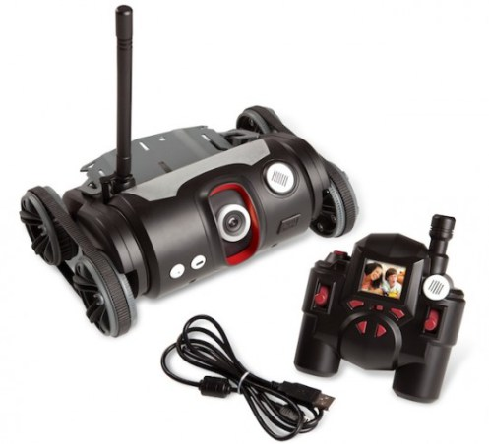

Interesting tank, I got one from an auction a long time ago, never did much with it, and somewhere I have the C complier downloaded for it. My remote never worked.

This has USB host mode, SD card reader, a Nordiac 2.4ghz chip (some say NRF24L01, others say that with additional firmware it can do wifi ????)

The website is still online, but the software and details about this toy are long gone, internet archive has some information, but not the downloads. (lost to history)

<https://funwithsnapcircuits.wordpress.com/2011/03/17/and-now-for-something-completely-different/>

Has some good information, but most of the links are dead now.

Roboni-i 2 Wheel Robot vehicle - has a Mega X (at least that is what they call it) and a special version of the Arduino IDE - still has lots of documention on the website.

<http://www.robonii.co.za/>

<http://www.robonii.co.za/index.php/downloads/arduino-download-page>

Roboni-i was made to be hackable, has lots going on inside it, including a RFID reader, arduino like compatible and it’s own special software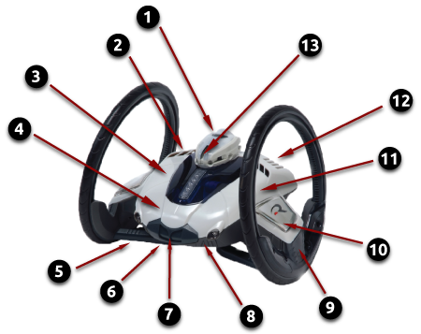 make this a very interesting toy.